Tutorial – Drawing and Mouse events
(Windows Store App)
Chih-Yu Kang
Ver. 1.0, 7th November, 2012
Bo Jun Chen
Ver. 3.0 24th November, 2016
Jyun Wei Chen
Ver. 4.0 21th November, 2022

Contents
About This Document 1
Tutorial – Drawing and Mouse events 1

About This Document
在本次的練習中，將會練習到如何在Windows Store App中使用Canvas繪出矩形和圓形，以及如何在Canvas中註冊點擊及移動的事件。
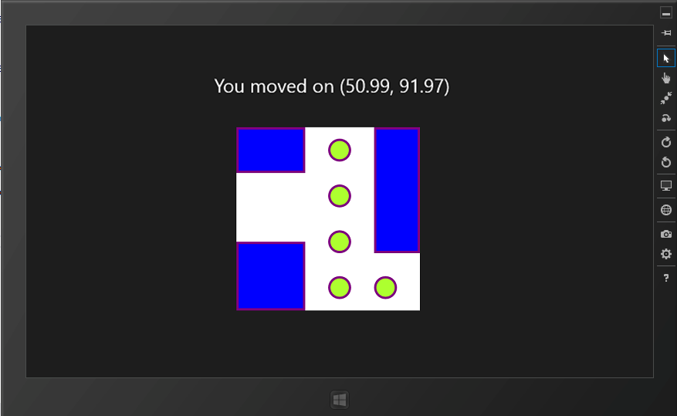
Figure 1 程式執行結果

Tutorial – Drawing and Mouse Events
- Setup Environment
打開Visual Studio 2019 Community後，建立新專案 > 選擇空白應用程式(通用 Windows)，如Figure 2，然後輸入專案名稱，如Figure 3，在 [新增通用 Windows 平台專案] 對話方塊中，接受預設的目標版本和最低版本設定，如Figure 4。即可成功建立一個空白的Windows Store App專案。
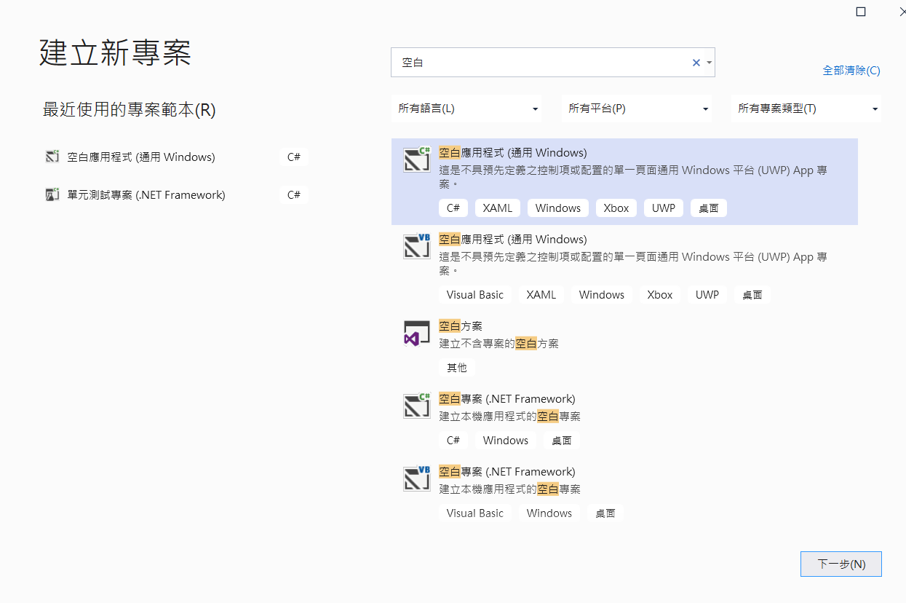
Figure 2 開啟新專案

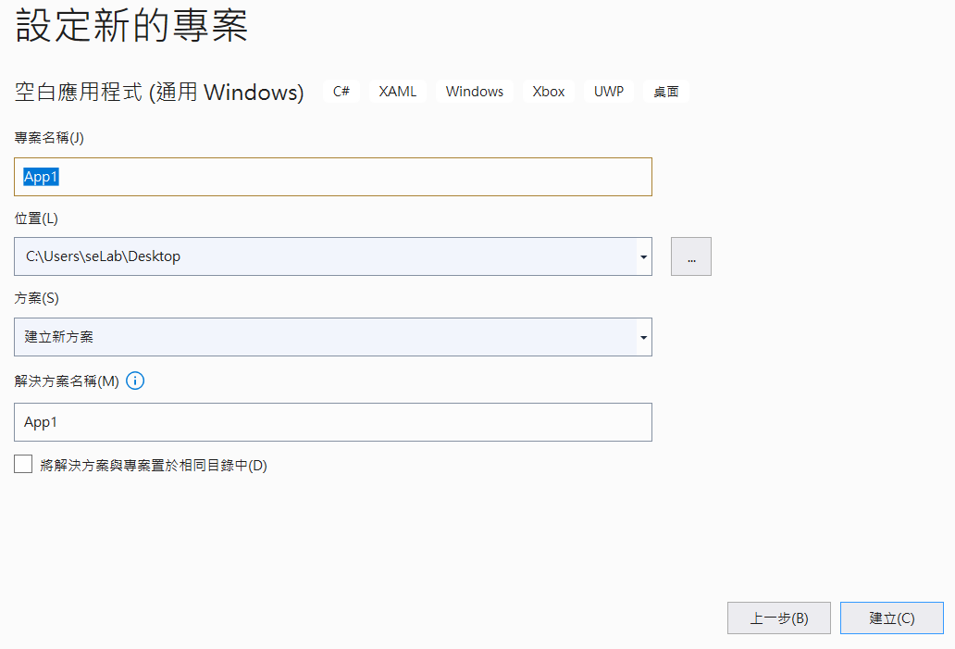
Figure 3 輸入專案名稱

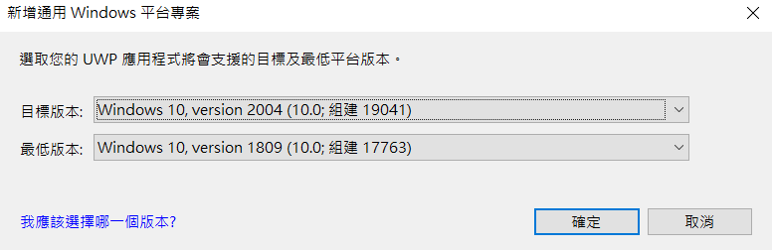
Figure 4 選擇預設的UWP版本

- Create a Canvas
從方案總管中，點選MainPage.xaml，從Toolbox中點選Canvas並拖拉至MainPage.xaml中，並將canvas 命名為 _canvas (Figure 5)。
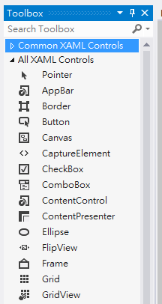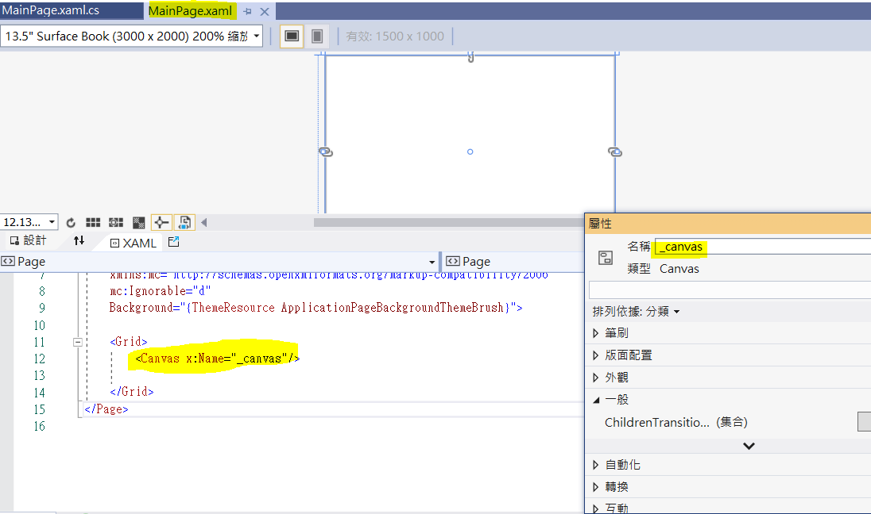
Figure 5 Toolbox拖拉canvas及命名

然後開啟MainPage.xaml.cs檔案，並且加入以下程式碼
public sealed partial class MainPage : Page
{
private const int CANVAS_SIZE = 400;
private const int BALL_SIZE = 50;
private const double STROKE_THICKNESS = 5;
private SolidColorBrush _whiteColor =
new SolidColorBrush (Colors.White);
private SolidColorBrush _blueColor =
new SolidColorBrush (Colors.Blue);
private SolidColorBrush _blackColor =
new SolidColorBrush (Colors.Black);
private SolidColorBrush _yellowColor =
new SolidColorBrush(Colors.Yellow);
private SolidColorBrush _greenYellowColor =
new SolidColorBrush(Colors.GreenYellow);
private SolidColorBrush _purpleColor =
new SolidColorBrush(Colors.Purple);
public MainPage()
{
this.InitializeComponent();
_canvas.Width = CANVAS_SIZE;
_canvas.Height = CANVAS_SIZE;
_canvas.Background = _whiteColor;
}
}
之後按下執行鍵 (Figure 6)，可以看到執行結果如Figure 7所示。
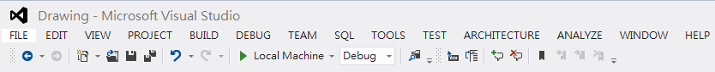
Figure 6 按下執行

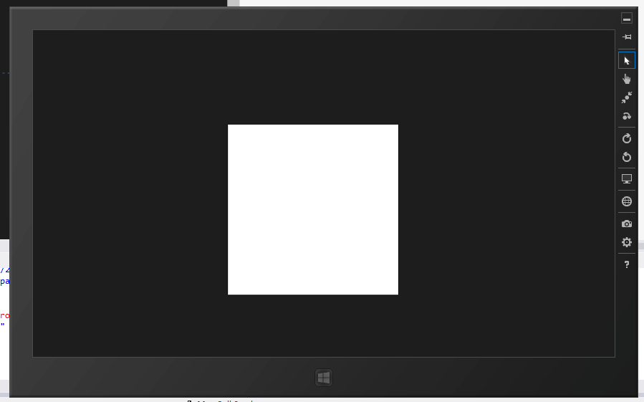
Figure 7 執行結果

- Draw some Rectangle and Ellipse
接著要在Canvas中加入一些圖形，先在MainPage.xaml.cs中加入InitializeShape的函式

private Shape InitializeShape(Shape shape, int left, int top, int right, int bottom, SolidColorBrush fillColorBrush)
{
shape.Margin = new Thickness(left, top, right, bottom);
shape.Width = right;
shape.Height = bottom;
shape.Fill = fillColorBrush;
return shape;
}

接著在MainPage()中加入：
// Three blue blocks
Rectangle rectangle = new Rectangle();
InitializeShape(rectangle, 0, 0, 150, 100, _blueColor);
_canvas.Children.Add(rectangle);

rectangle = new Rectangle();
InitializeShape(rectangle, 0, 250, 150, 150, _blueColor);
_canvas.Children.Add(rectangle);

rectangle = new Rectangle();
InitializeShape(rectangle, 300, 0, 100, 275, _blueColor);
_canvas.Children.Add(rectangle);

// Five balls
Ellipse ellipse = new Ellipse();
InitializeShape(ellipse, 200, 25, BALL_SIZE, BALL_SIZE, _greenYellowColor);
_canvas.Children.Add(ellipse);

ellipse = new Ellipse();
InitializeShape(ellipse, 200, 125, BALL_SIZE, BALL_SIZE, _greenYellowColor);
_canvas.Children.Add(ellipse);

ellipse = new Ellipse();
InitializeShape(ellipse, 200, 225, BALL_SIZE, BALL_SIZE, _greenYellowColor);
_canvas.Children.Add(ellipse);

ellipse = new Ellipse();
InitializeShape(ellipse, 200, 325, BALL_SIZE, BALL_SIZE, _greenYellowColor);
_canvas.Children.Add(ellipse);

ellipse = new Ellipse();
InitializeShape(ellipse, 300, 325, BALL_SIZE, BALL_SIZE, _greenYellowColor); _canvas.Children.Add(ellipse);

按下執行鍵，可以看到結果如Figure 8
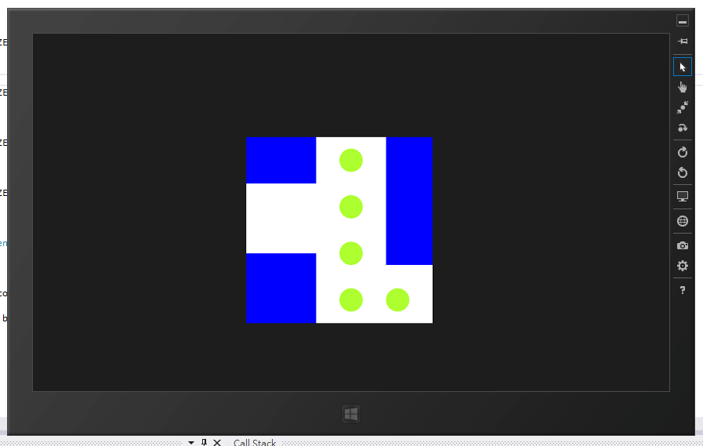
Figure 8 繪圖執行結果

- The shape StrokeThickness
做完剛剛的練習後，已經可以看到有三個矩形和五個圓形，接著我們要為他們加上外框，修改InitializeShape的副函式為以下，執行結果如Figure 9：
private Shape InitializeShape(Shape shape, int left, int top, int right,
int bottom, SolidColorBrush fillColorBrush)
{
shape.Margin = new Thickness(left, top, right, bottom);
shape.Width = right;
shape.Height = bottom;
shape.Fill = fillColorBrush;
shape.Stroke = _purpleColor;
shape.StrokeThickness = STROKE_THICKNESS;
return shape;
}

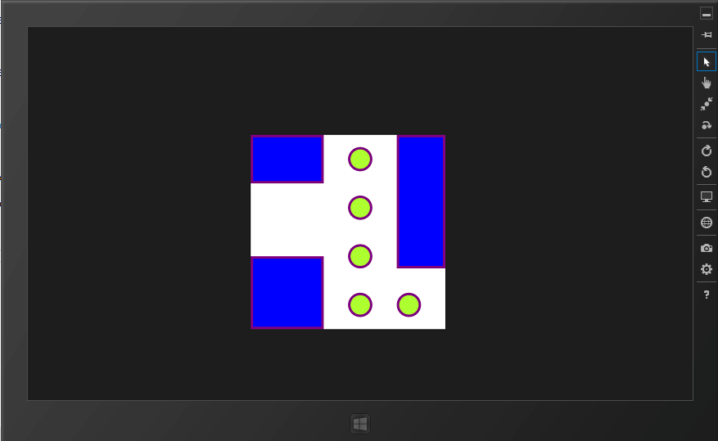
Figure 9 加上邊框執行結果
- Create a textBlock
在MainPage.xaml中，從工具箱加入一個textBlock放在canvas上方，將其命名為 _textBlock (命名方式同Step 2)，其textBlock與canvas的相對位置如 Figure 1。

- Add Mouse events
開啟MainPage.xaml.cs並在 MainPage() 中補充以下程式碼設定textBlock預設文字，以及註冊滑鼠點擊和移動的事件。
_textBlock.Text = "Where is the mouse?";
_canvas.PointerPressed += PressOnCanvas;
_canvas.PointerMoved += MoveOnCanvas;

然後我們在MainPage.xaml.cs中增加滑鼠點擊和滑鼠移動事件的方法。
//滑鼠點擊
private void PressOnCanvas(object sender, PointerRoutedEventArgs e)
{
double pressX = Math.Round(e.GetCurrentPoint(_canvas).Position.X, 2);
double pressY = Math.Round(e.GetCurrentPoint(_canvas).Position.Y, 2);
_textBlock.Text = "You pressed on (" + pressX + ", " + pressY + ")";
}

//滑鼠移動
private void MoveOnCanvas(object sender, PointerRoutedEventArgs e)
{
double moveX = Math.Round(e.GetCurrentPoint(_canvas).Position.X, 2);
double moveY = Math.Round(e.GetCurrentPoint(_canvas).Position.Y, 2);
_textBlock.Text = "You moved on (" + moveX + ", " + moveY + ")";
}

按下執行後，可以看到結果如Figure 1

- The End -

